**Today ( 6/1)**

* Finish Water Quality - (bing and Jin)
* Make the table of County (Mike)

|  |  |  |  |  |  |  |
| --- | --- | --- | --- | --- | --- | --- |
| CA | County | Longitude | Latitude | Population | Area | Population density |
|  |  |  |  |  |  |  |
| ... |  |  |  |  |  |  |
| ... |  |  |  |  |  |  |

**Saturday(6/2) and Sunday(6/3) we work on visualization**

**(Sat: 2PM - : Meeting at geisel , anyone can come if you have a time**

Visualization :

i) Scatter Point - ( we can talk about this more tmw)

ii) Water Quality Map - (Jin, Bing)

iii) using i) visualization,

1. Worst top 10 , -> ph, temp, turbidity , Oxygen
2. Top 10 population counties and put the map of

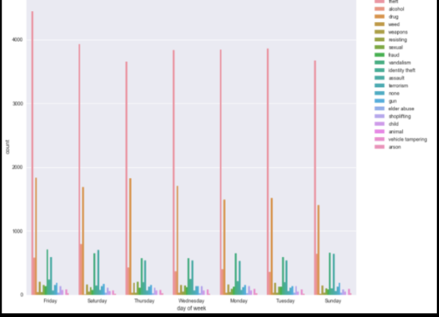 < sample>

**Monday (6/4) & Tuesday (6/5)**

Hopefully, start making ppt